**SECOND YEAR B. TECH THIRD SEMESTER**

**COMPUTER SCIENCE AND ENGINEERING DEPARTMENT**

**MINI PROJECT REPORT(ITW-1)**

ON

**Time Table – Generator**

By

**Siddh Jain (BT21CSE140)**



**INDIAN INSTITUTE OF INFORMATION TECHNOLOGY, NAGPUR**

**(An Institution of National Importance by Act of Parliament)**

**BACKGROUND OF PROJECT:**

A Python project that generates time table in excel sheet for given inputs of Subject for two section/shifts (Generally college or school timetable can be generated)

**METHODOLOGY:**

Openpyxl Library:

* Openpyxl is a python library to read/write Excel 2010 xlsx/xlsm/xltx/xltm files.
* The openpyxl module allows python program to read and modify Excel files.
* For example,

Users might have to go through thousands of rows and pick out a few handful of information to make small changes based on some criteria.

Using Openpyxl module, these tasks can be done very efficiently and easily.

* Use this command to install openpyxl module :

sudo pip3 install openpyxl

Tkinter :

* The tkinter package (“Tk interface”) is the standard Python interface to the Tcl/Tk GUI toolkit. Both Tk and tkinter are available on most Unix platforms, including macOS, as well as on Windows systems.
* Running python -m tkinter from the command line should open a window demonstrating a simple Tk interface, letting you know that tkinter is properly installed on your system, and also showing what version of Tcl/Tk is installed, so you can read the Tcl/Tk documentation specific to that version.
* Example: window.mainloop() tells Python to run the Tkinter event loop. This method listens for events, such as button clicks or keypresses, and blocks any code that comes after it from running until you close the window where you called the method.
* ttk - The tkinter.ttk module provides access to the Tk themed widget set, introduced in Tk 8.5. It provides additional benefits including anti-aliased font rendering under X11 and window transparency (requiring a composition window manager on X11).

**INTERFACE:**

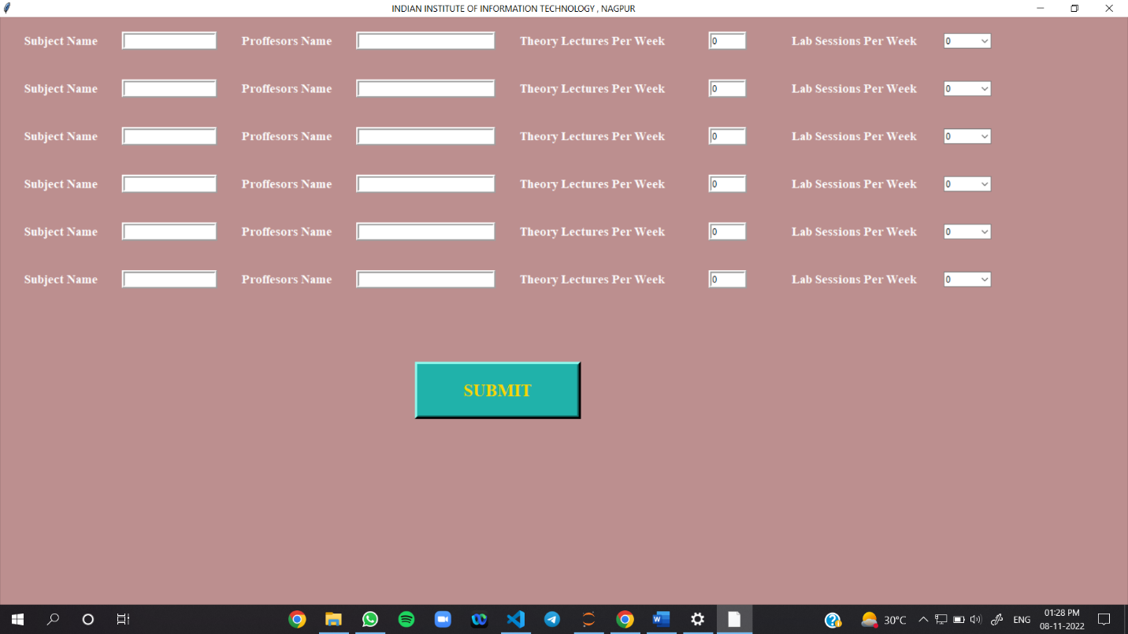

**RESULTS:**

